**CHAPTER 1**

**INTRODUCTION**

**1.1 OVERVIEW**

Machine learning is a field of [computer science](https://en.wikipedia.org/wiki/Computer_science) that gives [computers](https://en.wikipedia.org/wiki/Computer) the ability to [learn](https://en.wikipedia.org/wiki/Learn) without being explicitly programmed. Evolved from the study of [pattern recognition](https://en.wikipedia.org/wiki/Pattern_recognition) and [computational learning theory](https://en.wikipedia.org/wiki/Computational_learning_theory) in artificial intelligence, machine learning explores the study and construction of [algorithms](https://en.wikipedia.org/wiki/Algorithm) that can learn from and make predictions on [data](https://en.wikipedia.org/wiki/Data)– such algorithms overcome following strictly static [program instructions](https://en.wikipedia.org/wiki/Computer_program) by making data-driven predictions or decisions, through building a [model](https://en.wikipedia.org/wiki/Mathematical_model) from sample inputs. Machine learning is employed in a range of computing tasks where designing and programming explicit algorithms with good performance is difficult or in-feasible; example applications include [email filtering](https://en.wikipedia.org/wiki/Email_filtering), detection of network intruders or malicious insiders working towards a data breach, [optical character recognition](https://en.wikipedia.org/wiki/Optical_character_recognition) (OCR), [learning to rank](https://en.wikipedia.org/wiki/Learning_to_rank), and [computer vision](https://en.wikipedia.org/wiki/Computer_vision).

Machine learning is closely related to (and often overlaps with) [computational statistics](https://en.wikipedia.org/wiki/Computational_statistics), which also focuses on prediction-making through the use of computers. It has strong ties to [mathematical optimization](https://en.wikipedia.org/wiki/Mathematical_optimization), which delivers methods, theory and application domains to the field. Machine learning is sometimes conflated with [data mining](https://en.wikipedia.org/wiki/Data_mining), where the latter subfield focuses more on exploratory data analysis and is known as [unsupervised learning](https://en.wikipedia.org/wiki/Unsupervised_learning). Machine learning can also be unsupervised and be used to learn and establish baseline behavioural profiles for various entities and then used to find meaningful anomalies.

Glaucoma on the other hand is a condition that causes damage to eye's optic nerve and gets worse over time. It's often linked to a buildup of pressure inside [eye](https://www.webmd.com/eye-health/ss/slideshow-eye-conditions-overview). [Glaucoma](https://www.webmd.com/eye-health/video/glaucoma) tends to be inherited and may not show up until later in life. The increased pressure, called intraocular pressure, can damage the optic nerve, which transmits images to brain. If the damage continues, glaucoma can lead to permanent [vision loss](https://www.webmd.com/eye-health/coping-vision-loss). Without treatment, glaucoma can cause total permanent blindness within a few years. Most people with glaucoma have no early symptoms or pain.

Normally, the fluid, called aqueous humor, flows out of eye through a mesh-like channel. If this channel gets blocked, the liquid builds up. That’s what causes glaucoma. The reason for the blockage is unknown, but doctors do know it can be inherited, meaning it’s passed from parents to children. Less common causes include a blunt or chemical injury to eye, severe eye infection, blocked [blood](https://www.webmd.com/heart/anatomy-picture-of-blood) vessels inside the eye, and inflammatory conditions. It’s rare, but sometimes eye surgery to correct another condition can bring it on. It usually affects both [eyes](https://www.webmd.com/eye-health/video/eye-anatomy), but it may be worse in one than the other.

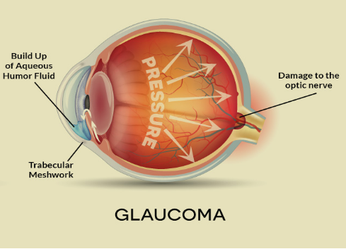  
**Figure 1.1 Glaucoma indication Diagram**

There are two major types of glaucoma. Primary open-angle glaucoma. This is the most common type of glaucoma. It happens gradually, where the eye does not drain fluid as well as it should (like a clogged drain). As a result, eye pressure builds and starts to damage the optic nerve. This type of glaucoma is painless and causes no vision changes at first. Some people can have optic nerves that are sensitive to normal eye pressure. This means their risk of getting glaucoma is higher than normal. Regular eye exams are important to find early signs of damage to their optic nerve.

### Angle-closure glaucoma (also called “closed-angle glaucoma” or “narrow-angle glaucoma”). This type happens when someone’s [iris](https://www.aao.org/eye-health/anatomy/iris-2) is very close to the [drainage angle](https://www.aao.org/eye-health/anatomy/drainage-angle) in their eye. The iris can end up blocking the drainage angle. It can be thought of like a piece of paper sliding over a sink drain. When the drainage angle gets completely blocked, eye pressure rises very quickly. This is called an acute attack.

**1.2 MOTIVATION**

According to [World Health Organization](http://www.who.int/en/), glaucoma is the second greatest cause of blindness worldwide. Glaucoma is known as the “silent thief of sight,” because in the most common form, there are typically no early symptoms as the disease sneaks up on its victims, robbing them of side vision first and then, over time, zeroing in until it’s like looking through a narrow tunnel, and finally, taking away vision altogether.

It affects more than 60 million people globally. When unchecked, this disease will sneakily reduce one’s vision until the loss is too severe to recover from. Early detection, through regular and complete eye exams, is the key to protecting vision from damage caused by glaucoma. A complete eye exam includes five common tests to detect glaucoma. There is no cure for this condition. Laser treatment may act to slow the progression of the disease and may be used to seal leaky blood vessels, and destroy abnormal vessels, lessening the scarring that will damage central vision.

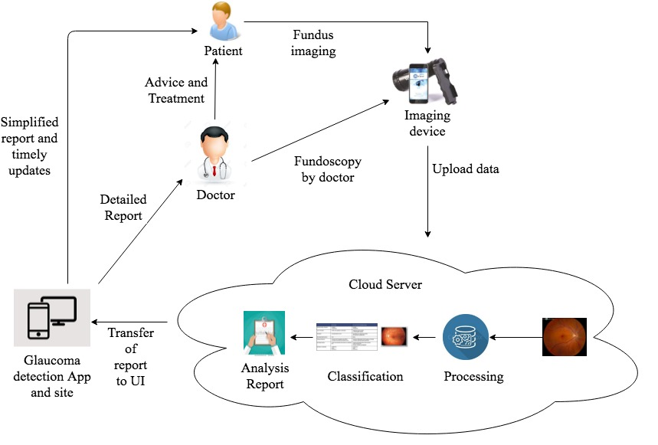

**Figure 1.2 Architecture Diagram**

**1.3 OBJECTIVE**

The main objective of the project is to facilitate the early detection of Glaucoma. Since Glaucoma has no symptoms initially, it is difficult to identify the disease at an early stage. Early detection and careful, lifelong treatment can maintain vision in most people. Having been associated with the higher-than- normal pressure inside the eye- a condition called as ocular hypertension, Glaucoma, if left untreated will first cause peripheral vision loss.

Based on the feed obtained from the fundoscopy device that captures the structural integrity and damages in eye, the presence or absence, current stage of the disease, etc. can be analysed. This is done by detecting cup to disc ratio from the obtained image from the fundoscopy device or the user’s mobile phone with the aid of ophthalmology lens. By implementing the concept of machine learning, the analysed data can be automatically drawn to a conclusion with a reasonable level of accuracy, thereby finding a solution. The results are highly personalized and the system will be equipped to provide timely updates and instruction to the patient ensure that proper care is given to the eye preventing the horrific effects that glaucoma can bring about. On using this method, if Glaucoma is detected at early stages, it will be helpful to the doctors to treat the patients effectively. If the proposed system is implemented, it will reduce the damages done by Glaucoma at large scale.

**1.4 ORGANIZATION OF THE REPORT**

This report is organized as follows: Chapter 2 gives a brief of description of the related work. Chapter 3 analyzes the system. The design of the system is discussed in Chapter4. The system implementation is mentioned in Chapter 5 and test results are highlighted in Chapter 6. Output of the system is explained in Chapter 7. Finally, conclusions are given Chapter 8 along with future scope. Appendix 1, Appendix 2 and Appendix 3 contain the sample code, screenshots and technical paper presentation certificates respectively. Reference contains list of paper which were referred for the project.

**CHAPTER 2**

**RELATED WORK**

# 2.1 LITERATURE REVIEW

# The paper [1] is about the annotated benchmark datasets which are essential for efficient detection of glaucoma using machine learning. With these datasets it is possible to very well sum find the cup-to-disc ratio. Fundoscopy and optical coherence tomography in retinal layers and optic nerve head of person affected by glaucoma at early phase. These structural indicators might help in diagnosis of glaucoma at early phase. Cup to disc ratio analysis using fundoscopy and analyzing retinal layer thickness using optical coherence tomography are among some of the structural changes used in glaucoma diagnosis. There are many autonomous computer aided diagnosis systems that helps ophthalmologists in analyzing the fundus and optical coherence tomography images using state of art biomedical imaging and machine learning techniques. Computer aided diagnostic systems helps in early detection of glaucoma in the areas where doctor to patient ratio is small. However, these algorithms require some annotated datasets for their evaluation and accuracy. Lack of annotated benchmark datasets with respect to cup to disc ratio for glaucoma detection has led to unavailability of comparison and evaluation of glaucoma detection algorithm globally. Proposed research aims to provide an annotated dataset with respect to glaucoma detection. Annotations are done from multiple ophthalmologists. This dataset will enable in future to measure the accuracy of proposed algorithms based on Cup to disc ratio analysis.

The paper [2] discusses the method for detection of glaucoma by conducting analysis on structural and non-structural features of the retina. The retinal images are analyzed based on its cup, disc and their ratio as well as other features like intensity, texture and so on. Glaucoma progression precedes some structural changes in the retina which aid ophthalmologists to detect glaucoma at an early stage and stop its progression. Fundoscopy is among one of the biomedical imaging techniques to analyze the internal structure of retina. The proposed technique provides a novel algorithm to detect glaucoma from digital fundus image using a hybrid feature set. This paper proposes a novel combination of structural (cup to disc ratio) and non-structural (texture and intensity) features to improve the accuracy of automated diagnosis of glaucoma. The proposed method introduces a suspect class in automated diagnosis in case of any conflict in decision from structural and non-structural features. The evaluation of proposed algorithm is performed using a local database containing fundus images from 100 patients. This system is designed to refer glaucoma cases from rural areas to specialists and the motivation behind introducing suspect class is to ensure high sensitivity of proposed system. The average sensitivity and specificity of proposed system are 100 and 87 % respectively.

# 

# The paper [3] is about the detection of glaucoma based on the structural features of the retinal images obtained. On analyzing the structural features, the result is generated. Functional features are observed by visual field testing and to observe structural features Optical Coherence Tomography (OCT) and fundus images are the most widely used medical imaging techniques. Optic Nerve Head (ONH), Retinal layers are the key source and most repeatable structural features to detect structural changes in the retina of glaucomatous eyes. This paper presents a review on different glaucoma detection techniques from clinical and machine learning perspectives. The paper also highlights the functional and structural features and their significance with respect to digital fundus and OCT images for glaucoma detection. It concludes that structural features are more precise for early glaucoma detection as compared to functional features. Moreover, using hybrid features in training classifiers and correlating results of both fundus and OCT images can yield more accurate results.

# The paper [4] discusses the automated detection technique for finding the existence of glaucoma. The technique is Optical Coherence tomography (OCT). With OCT it is possible to inspect the structure and texture of retinal parts based on which it is possible to get the result. There is no known cure of glaucoma at final stage. There is a need to develop automated glaucoma detection systems that are able to detect glaucoma at an early stage where it can be treated. Glaucoma detection can be effectively achieved using Optical Coherence Tomography (OCT) at an early stage where it could be treated. The evidence that automated glaucoma detection at the last stage is at a mature level using fundus images however there is a great margin of improvement in automated glaucoma detection using OCT is found. It was proposed to use a hybrid feature set consisting of both structural and texture features of retinal image for more accurate glaucoma detection.

# The paper [5] contributes to the project by discussing automated glaucoma detection by using Convolution neural network which is a deep learning technique. This paper addresses the feasibility of developing an automatic feature learning technique for detecting glaucoma in coloured retinal fundus images using a deep learning method. A fully automated system based on Convolution Neural Network (CNN) is developed to distinguish between normal and glaucomatous patterns for diagnostic decisions. Unlike traditional methods where the optic disc features are handcrafted, the features are extracted automatically from the raw images by CNN and fed to the SVM classifier to classify the images into normal or abnormal. Here is demonstrated an accuracy, specificity and sensitivity of 88.2%, 90.8%, and 85%, respectively which compared favourably to the-state-of-the-art but at considerably lower computational cost.

The author of the paper [6] describes the technique to find the cup to disc ratio using k-means clustering algorithm. The paper contributes to the project by discussing the method of Region of Interest (ROI) to find CDR. Although the disease of Glaucoma is incurable but its symptoms can be minimized therefore early detection of the disease is essential. Elevated intraocular pressure, gradual vision loss which is a step towards blindness, structural damage to the retina are the marked symptoms of Glaucoma. Manually, It is diagnosed by examination of size, structure, shape of optic disc and optic cup. In patient of glaucoma Cup size increases while disc area remains the same hence cup to disc ratio (CDR) increases in glaucoma patient. CDR is the ratio of optic cup area to the optic disc area, which provides basis for the diagnosis of glaucoma. This article focuses on automated detection of glaucoma from fundus images using CDR. Region Of Interest (ROI) extraction through intensity weighted centroid method which is followed by pre-processing and recursively applied k-mean clustering segmentation for the detection of Optic Cup (OC) and Optic Disc (OD). Ellipse fitting is implied for boundary smoothening of OC and OD. Performance of the proposed technique is assessed on 100 fundus images collected locally. Proposed approach gives an accuracy of 92% for glaucoma and Mean square error of 0.002 for CDR.

# The paper [7] is about the classification of glaucoma existing images from those that don’t. This is achieved by processing the image i.e.,: removing the in homogeneities and vessel structures and the applying the resulting image to the classifier. This author devised a novel, automated, appearance based glaucoma classification system that does not depend on segmentation based measurements. The purely data-driven approach is applicable in large-scale screening examinations. It applies a standard pattern recognition pipeline with a 2-stage classification step. Several types of image-based features were analyzed and are combined to capture glaucomatous structures. Certain disease independent variations such as illumination inhomogeneities, size differences, and vessel structures are eliminated in the pre-processing phase. The “vessel-free” images and intermediate results of the methods are novel representations of the data for the physicians that may provide new insight into and help to better understand glaucoma. The system achieves 86 % success rate on a data set containing a mixture of 200 real images of healthy and glaucomatous eyes. The performance of the system is comparable to human medical experts in detecting glaucomatous retina fundus images.

The paper [8] deals with glaucoma detection using Fundus images and OCT method. With either of these images the structural features of the retina is analyzed using Retinal Layer Analysis and Optic nerve head analysis. Till date many works have been done towards automatic glaucoma detection using Colour Fundus Images (CFI) and Optical Coherence Tomography (OCT) images by extracting structural features. Structural features can be extracted from optic nerve head analysis in case of CFI and Retinal Layers analysis in OCT images for glaucoma assessment. But unfortunately, the works till date fall short of expected accuracy in this regard. A review of automated glaucoma detection techniques is presented in this paper. The paper also discusses various structural features that are relevant to CFI and OCT images respectively for automated glaucoma detection. The paper concludes that combining structural features from both CFI and OCT images would result in more accurate glaucoma assessment.

# The paper [9] contributes by discussing the automated detection of glaucoma using support vector machine. In this it is possible to detect the disease by performing Principle Component Analysis (PCA). This is one of the efficient ways to detect glaucoma. This article discusses some techniques used for glaucoma diagnosis. in this paper a supervised learning is proposed and compared with other existing techniques for the detection of glaucoma. For classification support vector machines principle is used. Nonlinear transformation of the support vectors is used and classification can be done. The retinal fundus images of the databases are taken for the glaucoma detection. The proposed classifier will take these images and formation of the presence/absence of glaucoma by calculating the CDR value in the respected image. The features of the images are extracted by using PCA (Principle Component Analysis). The accuracy, predictability of the proposed classifier is compared with the techniques which includes fused method and Support vector machine by morphological based image classification.

# 2.2 INFERENCE OF THE LITERATURE REVIEW

In paper [1], it concludes that, annotated benchmark datasets which are essential for efficient detection of glaucoma using machine learning. With these datasets it is possible to very well find the cup-to-disc ratio.

In paper[2], it concludes that, the method for detection of glaucoma by conducting analysis on structural and non-structural features of the retina. The retinal images are analyzed based on its cup, disc and their ratio as well as other features like intensity, texture and so on. Glaucoma progression precedes some structural changes in the retina which aid ophthalmologists to detect glaucoma at an early stage and stop its progression

In paper[3], it concludes that, the detection of glaucoma based on the structural features of the retinal images obtained. On analyzing the structural features, the result is generated. Functional features are observed by visual field testing and to observe structural features Optical Coherence Tomography (OCT) and Fundus images are the most widely used medical imaging techniques.

In paper[4], it concludes that, the automated detection technique for finding the existence of glaucoma. The technique is Optical Coherence tomography (OCT). With OCT it is possible to inspect the structure and texture of retinal parts based on which it is possible to get the result.

The paper [5] contributes to the project by discussing automated glaucoma detection by using Convolution neural network which is a deep learning technique. This paper addresses the feasibility of developing an automatic feature learning technique for detecting glaucoma in coloured retinal fundus images using a deep learning method.

In paper[6],it concludes that, describes the technique to find the cup to disc ratio using k-means clustering algorithm. The paper contributes to the project by discussing the method of Region of Interest (ROI) to find CDR. Although the disease of Glaucoma is incurable but its symptoms can be minimized therefore early detection of the disease is essential.

In paper[7], it discusses, about the classification of glaucoma existing images from those that don’t. This is achieved by processing the image i.e,: removing the in homogeneities and vessel structures and the applying the resulting image to the classifier.

In paper[8], it discusses about the glaucoma detection using Fundus images and OCT method. With either of these images the structural features of the retina is analyzed using Retinal Layer Analysis and Optic nerve head analysis.

In paper[9], it discusses about,the automated detection of glaucoma using support vector machine. In this it is possible to detect the disease by performing Principle Component Analysis (PCA). This is one of the efficient ways to detect glaucoma. This article discusses some techniques used for glaucoma diagnosis.

**CHAPTER 3**

**SYSTEM ANALYSIS**

**3.1 PROBLEM DEFINITION**

Glaucoma is an eye disease which is the second most cause for blindness worldwide. It is infamously renowned as the “Silent thief of sight”. Being an initially unnoticeable disorder, glaucoma will cause an irreversible vision loss by the time it is realized by the patient through vision difficulties. Glaucoma has no symptoms during its early stages which makes it more dangerous. The contemporary system to detect glaucoma, with a series of test, is complicated and, weighs economically on the patient. This makes it difficult for many to detect glaucoma in its early state. The removal of such complexity from the system will prove to a valuable contributor to the increase in the number of patients in whom glaucoma is detected in its early stages. This will help reduce the continued expenditures on medication on the condition getting worse and also will prevent the eye from losing sight permanently.

This project aims at introducing machine learning to detect the disorder in its early stage. If the disease is detected in its early stage, the appropriate medication can be prescribed effectively to prevent it from causing more damage to the patient’s vision**.**

**3.2 PROPOSED SYSTEM**

The proposed model consists of a mobile app which basically deals with all the front end processes and functionalities of the system. Initially, the patient’s retinal image, also known as the fundus image, is obtained using a fundoscopy machine by an ophthalmologist. The captured fundus image is uploaded to the cloud by the ophthalmologist in order to carry out basic processing like noise removal. Later the image is analyzed to detect the disc structure and is cropped on the borders of the disc. Following it, the cup structure is analyzed and is cropped accordingly. With the obtained cropped images the cup-to-disc ratio is determined with the diameters of both the images and finding their ratio.

With the CDR value, the classification process is carried out by applying the CDR value to the highly trained classifier. Linear Regression is the algorithm in use, to train the classifier as it has the highest accuracy of all. The classifier gives the analysis for glaucoma in a detailed manner to the doctor and abstracted version to the user. The output is forwarded to the app and thus the patient obtains the result. Based on the result, the patient can seek a doctor’s advice and follow medication.

**3.3 ADVANTAGES**

* Early detection avoids the cost of advanced medication.
* Controls the severity and thereby the effects.
* Simple process.
* The mobile app is handy with no hand work involved.
* User-friendly and understandable.
* Reduction in the hardware costs.

**3.4 SYSTEM SPECIFICATION**

**3.4.1 Software Requirements**

Operating system : Windows

Technology Used : Android 7.0, Machine Learning, Cloud Computing

IDE : Android studio, Pycharm, Spyder

Database : MYSQL

Tools used : Android SDK, Anaconda, OpenCV, Pillow, Django

Language used : Python, Java, XML, HTML

**3.5 LANGUAGE SPECIFICATION**

The programming language used to develop most of the modules is Python. Since python is simple and efficient with several libraries and compatibility factors, it tends to be the best fit for this purpose. Python is used in the image processing module to program ROI in order to crop the required region of the subject image. And also to calculate the C to D Ratio. In the machine learning module, it is used to import the dataset, pre-process the data, split the dataset into train and test sets and train the classifier. With that, the required result is predicted for the respective input given..

Android app is an essential component of this project and is developed using java and XML. The reason being that the developed app works best and will be lightweight and agile if it’s a native app instead of a hybrid version. HTML is used along with some popular frameworks like bootstrap and jQuery to develop a interactive web portal.

**3.6 SERVER**

Django framework is used to establish and develop the server. Django is a powerful and efficient web framework developed in python and follows the model-view-template architectural pattern that enables developers create highly able and feature rich web applications with east. It also has well defined libraries that allow for extensive development by reducing the need to have redundant code written. In this project Django is used to develop the application server to be deployed in cloud. The application is deployed in a Virtual Private Server, making it accessible by all and eventually qualifying it as SaaS.

The web page is essentially a web app that is an integrated part of the many functions of Django. It The application server will then on perform action like user creation, handling request, saving images, maintaining database, performing image analysis, machine learning through regression and send out result to app and web page. All under the single environment created through Django.

**3.7 DATABASE**

In this project the database used is MySQL. It is connected to the Django server using the mysqlclient, a package in python. The database serves to be the pivotal point of coordination among various modules. It holds in it, intermediate results that acts as input later on.

It saves the user details for validation and authentication , saves locations of fundus images, records the CDR values of the patient with their details and the image detail and finally saves the result of the linear regression module with correspondence to the user.

**3.8 USE CASES**

**USE CASE UC 1**

**Scope** **-** Glaucoma Application

**Level** **-**User goal

**Primary Actor** **-** User

**Stakeholders and Interests**

**User -** User wants to access the records and perform analysis.

**Preconditions** **-** User is identified and authenticated.

**Success Guarantee** **-** The user is able to access the patient records and perform the analysis with the input image as well.

**Main Success Scenario**

* User has to register or login with the required credentials.
* The doctor is allowed to capture the image and then it is input.
* The input is uploaded to the server.
* The analysis runs in the cloud environment and the result is sent back to the application.
* The result is displayed to the user.

**Extensions**

If the password in invalid,

* application shows a message “**password invalid**”
* If the user is patient, the user cannot capture image.

**Technology Used**

* Android studio is used to develop the mobile application.

**Frequency of Occurrence**-As per user request.

**CHAPTER 4**

**SYSTEM DESIGN**

**4.1 OVERALL ARCHITECTURE**

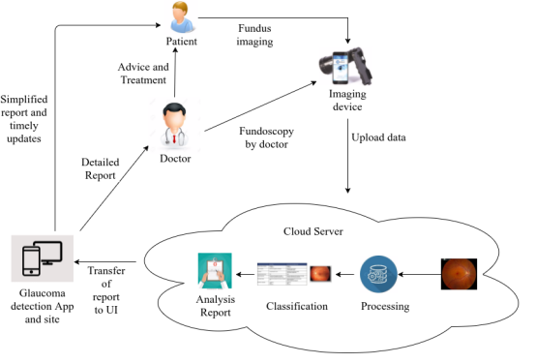

**Figure 4.1 Glaucoma Detection**

The proposed model consists of a mobile app which basically deals with all the front end processes and functionalities of the system. Initially, the patient eye is being captured using fundoscopy by the doctor. The captured input image is forwarded to the cloud in order to carry out basic processing. Later the image is analyzed to detect the disc structure and is cropped on the borders of the disc. Following it, the cup structure is analyzed and is cropped accordingly. With the obtained cropped images the cup-to-disc ratio is determined with the diameters of both the images and finding their ratio. With the CDR value, the classification process if carried out by applying the CDR value to the highly trained classifier. The classifier gives out the result as output with its level of accuracy. Normally Linear Regression is the preferred algorithm to train the classifier as it has the highest accuracy of all. The output is forwarded to the app and thus the patient obtains the result. Based on the result, the patient can seek a doctor’s advice and follow medication.

**4.2 MODULE DESCRIPTION**

Mainly this application is used to detect Glaucoma at its early stage. It is created for the user who is the patient to get the results of the analysis of his/her Glaucoma test and also access the records. For doctor it is used to analyze the patient data and get the results. Later the doctor prescribes medication accordingly. The system consists of the following modules.

* Image Capture and Validation
* Image Pre-processing
* CDR determination
* Analysis

**4.2.1 Image Capture and Validation**

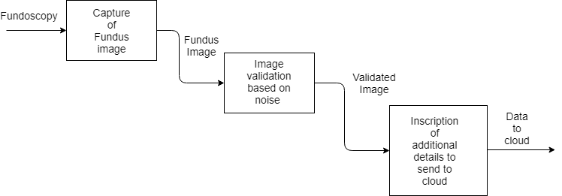

**Figure 4.2 Image Capturing and validation**

The Image Capture and Validation is the first module in the system. The image of the patient’s retina is being captured by the fundoscopy device. It is handled by the doctor or technician. The captured image is called the fundus image which is then checked if suitable to conduct further analysis. If it satisfies the conditions, then it is said to be valid and that concludes the validation part. The resultant image is forwarded to the following phase of Image Pre-Processing.

**4.2.2 Image Pre-processing**

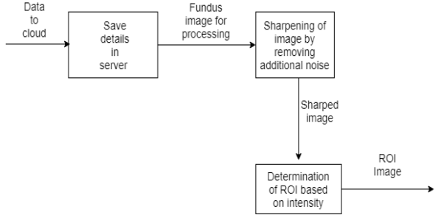

**Figure 4.3 Image Pre-processing**

The next phase in the system is Image Pre-processing. In image pre-processing module, the image obtained from the previous phase is given as input and is processed for further analysis.

Here the obtained image is converted into binary image which is made of just black and white pixels. Then a loop is run from the leftmost pixel towards the border of the disc. In retinal part of the eye, there are two circular structures which play a key role in the determination of glaucoma. They are the cup and the disc. The disc is the outer circle which encircles the cup which is in the shape of a cup. When the loop stops at the appropriate pixel, it is noted. Similarly another loop from the right is run to find the right side border. Then the image is cropped at the borders. The same process is repeated for cup and the image is cropped. Thus two images are obtained, one of the disc and another cup. Both the images are forwarded to the next phase where the CDR is determined.

**4.2.3 CDR Determination**

The two images are obtained after being processed at the previous phase. Those images are considered to determine the CDR which is also called as Cup-to-Disc Ratio. The CDR is determined using the following steps. The width of the image of Disc is found. The width is exactly the same value as that of the diameter of the disc. Similarly the diameter of the cup is determined using the width value of the cup image. After obtaining both the values, they are applied to the following formula to determine the CDR value.

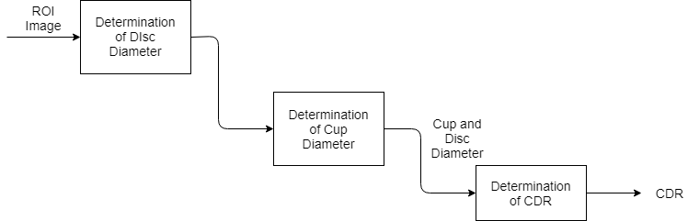

**Figure 4.4 CDR Determination**

.

Here the diameter of the cup is divided by that of the disc and ratio value of two decimal places is obtained. Thus CDR value is determined. The CDR plays a key role in the determination of Glaucoma and has a vital part in the system. It is based on the CDR value. Thus, glaucoma existence, as well as severity is determined.

**4.2.4 Analysis**

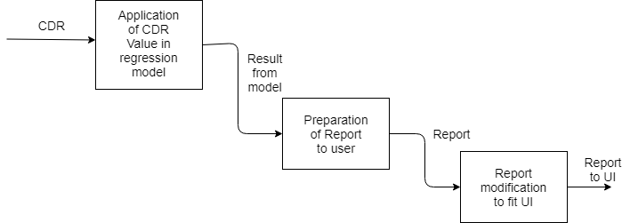

**Figure 4.5 Analysis**

The last module of the system is Analysis. Analysis phase involves machine learning. In this, a machine learning classifier is trained using a huge dataset and is trained to the best accuracy. The classifier is trained using Linear Regression. When CDR value of a patient is obtained, it is applied to the classifier. The classifier based on it accuracy, gives a solution. Thus the output is obtained along with the severity of glaucoma. A raw report is prepared and is optimized according to the UI. Later the obtained report is forwarded to the application for the users to access it.

**4.2.5 Use Case Diagram**

This use case is an interaction between users and a system. This Use Case diagram captures use cases and actor interactions of the user with the database. It describes the functional requirements of the system from the user. The use cases have its own properties and constraints that has to be fulfilled by the user in order to access the database. The sequence of events between user and database is pictured as use cases.

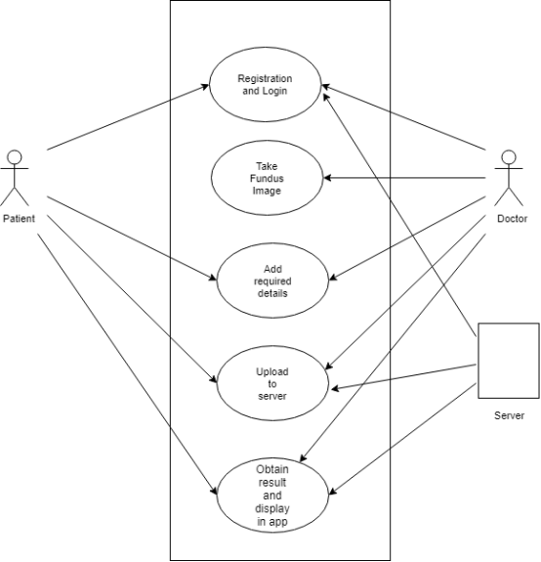

**Figure 4.6 Use case Diagram**

**4.2.6 Class Diagram**

The Class diagram describes the structure of a system by showing the systems classes, their attributes, and the relationships of the user with the database is explained in this class diagram. The classes in this diagram represent both the main objects and or interactions of the user and database.

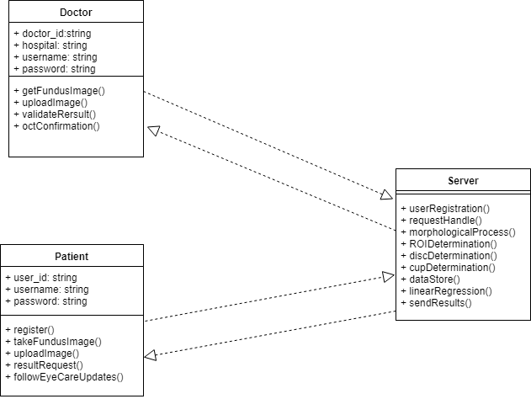

**Figure 4.7 Class Diagram**

**4.2.7 Activity Diagram**

The complete working of the system from the new user registration to the passing messages to the user from another mobile is graphically represented with step-wise activities and actions. The flow of activities involving the conditions whether to do or not to do an action is also explained.

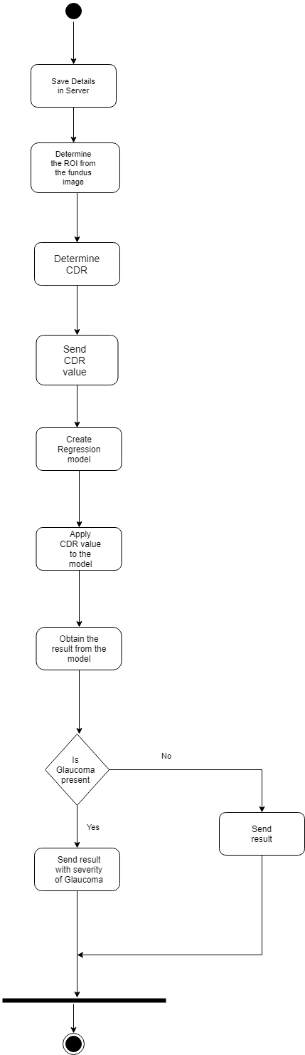

**Figure 4.8 Activity Diagram**

**4.3 DESIGN SCHEMA**

**4.3.1 Database Structure**

**Table 4.1 Doctor Database**

|  |  |  |  |
| --- | --- | --- | --- |
| **Field** | **Type** | **Constraints** | **Description** |
| id |  | Primary key | ID of the doctor |
| name | Varchar |  | Name of Doctor |
| email | Varchar |  | Mail ID of doctor |
| pass | Varchar |  | Password of Doctor |
| phone | integer |  | Phone Number of Doctor |

**Table 4.2 Patient Database**

|  |  |  |  |
| --- | --- | --- | --- |
| **Field** | **Type** | **Constraints** | **Description** |
| id |  | Primary Key | ID of the patient |
| name | Varchar |  | Name of patient |
| email | Varchar |  | Mail ID of patient |
| pass | Varchar |  | Password of patient |
| phone | integer |  | Phone Number of patient |

**Table 4.3 Test/Results Database**

|  |  |  |  |
| --- | --- | --- | --- |
| **Field** | **Type** | **Constraints** | **Description** |
| id |  | Primary key | ID of test |
| patient_id | integer |  | ID of patient |
| doctor_id | integer |  | ID of doctor |
| img | varchar |  | Image of retina |
| cdr | double |  | CDR value |
| severity | double |  | Severity of Glaucoma |
| date | date |  | Date of test |

**Table 4.4 Image Database**

|  |  |  |  |
| --- | --- | --- | --- |
| **Field** | **Type** | **Constraints** | **Description** |
| id |  | Primary Key | log ID |
| patient_id | integer |  | ID of patient |
| img_loc | Varchar |  | Location of image |
| date | date |  | Date of upload |

**CHAPTER 5**

**SYSTEM IMPLEMENTATION**

**5.1 ALGORITHM AND TECHNIQUES USED**

**5.1.1 Pseudocode**

**5.1.1.1 Image Pre-processing**

Get image input img

//Function for Cup

Cup(){

Convert to Binary

gray = img.convert('L')

Determine height

height = img.height

Determine Intensity

bw = x=0 if x<160 else x=1

Read the result image

img1 = cv2.imread('result_cup.jpg')

x = height / 2

y =0

y1 = width - 1

while (Pixel->black)

inc y

r= image

while (pixel->black)

dec y1

r1 = image

Region of interest

roicup = img[0->height , left(y)->right(y1)

}

//Function for disc

Disc(){

Convert to Binary

gray = img.convert('L')

Determine height

height = img.height

Determine Intensity

bw = x=0 if x<125 else x=1

Read the result image

img1 = cv2.imread('result_cup.jpg')

x = height / 2; y =0;

y1 = width - 1

while (Pixel->black)

inc y

r= image

while (pixel->black)

dec y1

r1 = image

Region of interest

roidisc = img[0->height , left(y)->right(y1)]

}

**5.1.1.2 Cup-to-Disc Determination**

Determine the cup diameter w1

w1 = float(p_img.width)

Determine the disc diameter w2

w2 = float(p_img1.width)

Determine the ratio

ratio = round(w1/w2,2)

* Obtain the fundus image from the project directory using Image.open(Path_of_the _image) in img variable
* Convert img to black and white using img.convert()
* Trim the image to the first white pixel on either side from center and obtain the width of the image using img.width(), to get the width of disc.
* From the trimmed image perform the same operation to get width of cup
* Determine the CDR using the width of the two images

 (5.1)

**5.1.1.3 Analysis**

* Obtain the .csv file containing the CDR value and severity values, using the read_csv() function.
* Segregate the obtained dataset into test and train set using train_test_split() of sklearn library.

X_train,X_test,Y_train,Y_test = train_test_split(X,Y,train_size ,random_state )

regressor = LinearRegression()

regressor.fit(X_train, Y_train)

* Predict the severity for CDR using

y = B0 + B1 * x,

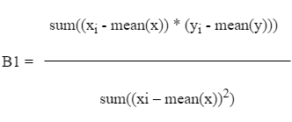(5.2)

B0 = mean(y) – B1 * mean(x)

Where,

* x is the input, independent variable (CDR)
* y is the dependent variable which is being predicted(Severity)
* B0 is the intercept.
* B1 is the slope
* xi & yi are the ith value of x and y
* Print the Predicted Value

**5.2 WORKING**

The proposed model consists of a mobile app which basically deals with all the front end processes and functionalities of the system. Initially, the patient eye is being captured using fundoscopy by the doctor. The captured input image is forwarded to the cloud in order to carry out basic processing. Later the image is analyzed to detect the disc structure and is cropped on the borders of the disc. Following it, the cup structure is analyzed and is cropped accordingly. With the obtained cropped images the cup-to-disc ratio is determined with the diameters of both the images and finding their ratio. With the CDR value, the classification process if carried out by applying the CDR value to the highly trained classifier. The classifier gives out the result as output with its level of accuracy. Normally Linear Regression is the preferred algorithm to train the classifier as it has the highest accuracy of all.The output is forwarded to the app and thus the patient obtains the result. Based on the result, the patient can seek a doctor’s advice and follow medication.

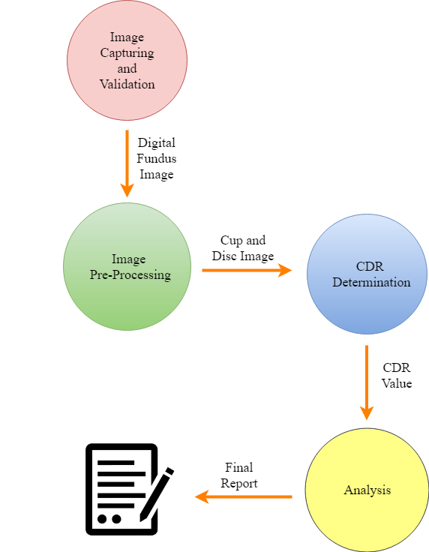

**Figure 5.1 Working Diagram**

**CHAPTER 6**

**SYSTEM TESTING**

**6.1 TEST CASES**

**6.1.1 Test Case 1**

**Table 6.1 Test Case for Image Pre-processing**

|  |  |
| --- | --- |
| **Project Name:** cloud Based Detection of Glaucoma using Machine Learning | |
| **Test Case Id:**<01> | **Test Designed by:** Balasubramaniam T |
| **Test Priority:** High | **Test Designed on:** 14-02-2018 |
| **Module Name:** Image Pre-Processing | **Test Executed by:** Ashwath **S** |
| **Test Title:** Extraction of Cup and Disc from Fundus image | **Test Executed Date:** 19-02-2018 |
| **Description :** To Extract the Cup and Disc from Fundus image using ROI Technique**.** | |
| **Pre-condition:** User need to login before uploading image for Pre-processing | |

**Table 6.2 Test Case for Image Pre-processing**

|  |  |  |  |  |  |
| --- | --- | --- | --- | --- | --- |
| Step | Test Step | Test Data | Expected Result | Actual Result | Status |
| 1 | Converting to Black and white image | Digital Fundus image | Black and white image | Black and white image | Pass |
| 2 | Locating the Cup and Disc Border | Black and White Image | A white pixel Point on the Border of Cup and Disc | A white pixel point on Border of cup and disc | Pass |
| 3 | Cutting the Cup and Disc portion | Black and white image with White pixel | Cup and Disc processed image | Cup and Disc Processed image | Pass |
| 4 | Determine CDR Value | Cup and Disc | CDR value | CDR Value | Pass |

**6.1.2 Test Case 2**

**Table 6.3 Test Case for Machine Learning Module**

|  |  |
| --- | --- |
| **Project Name:** cloud Based Detection of Glaucoma using Machine Learning | |
| **Test Case Id:**<02> | **Test Designed by:** Ashwath S |
| **Test Priority:** High | **Test Designed on:** 04-03-2018 |
| **Module Name:** Cup-to-Disc Determination | **Test Executed by:**Balasubramaniam T |
| **Test Title:** Prediction of severity for input CDR | **Test Execution Date:** 08-03-2018 |
| **Description :** Obtaining the best-fitting line for the training data set and thus predict the severity for unknown value. | |
| **Pre-Condition:** CDR Value must be determined. | |

**Table 6.4 Test Case for Cup-to-Disc Determination**

|  |  |  |  |  |  |
| --- | --- | --- | --- | --- | --- |
| Step | Test Step | Test Data | Expected Result | Actual Result | Status |
| 1 | Obtain the dataset from the system | CSV file containing dataset | Transfer of dataset into object | Transfer of dataset into object | Pass |
| 2 | Splitting the dataset into test and train set | Object containing dataset | Two datasets, namely test and train | Two datasets, namely test and train | Pass |
| 3 | Train the regression model using the train dataset | Train dataset | Trained module with best fitting line | Trained module with best fitting line | Pass |
| 4 | Predict the Severity  for Test dataset | Test dataset | Severity of the input CDR | Severity of the input CDR | Pass |

**CHAPTER 7**

**OUTPUT AND EXPLANATION**

**7.1 OUTPUT**

This chapter is dedicated to showcase the output screenshots from the web app and the android application to create a more deeper understanding of the whole layout.

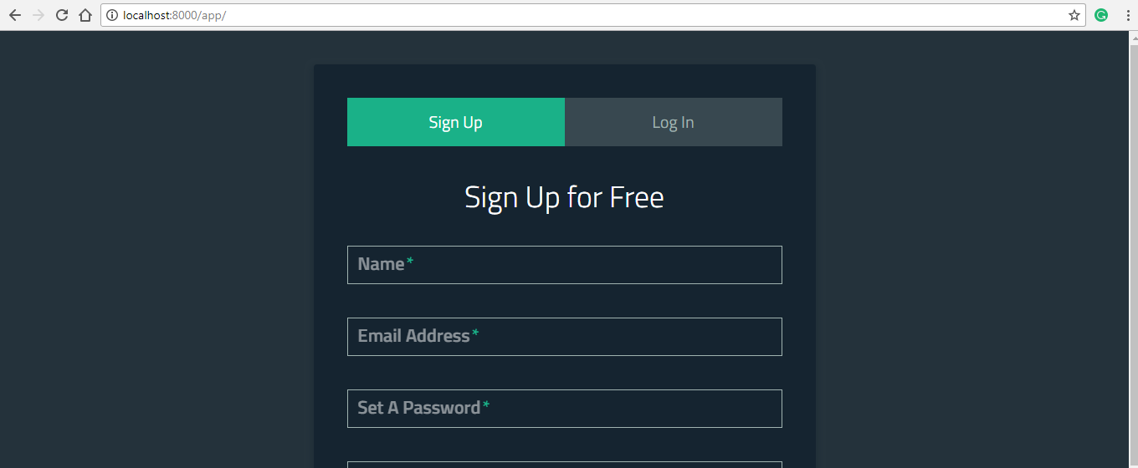

**Figure 7.1 Screenshot of User Registration and Authentication**

Figure 7.1 shows the screenshot of user registration and authentication. The user upon accessing the web application is required to enrol into the system either as a patient or as a doctor as per their qualification.This is a single point authentication for the system and does not include any other authentication down the line. Once the user has enrolled he is eligible to access the service. The user is then authenticated with the respective credentials provided at the time of signup and is directed to their respective dashboards.

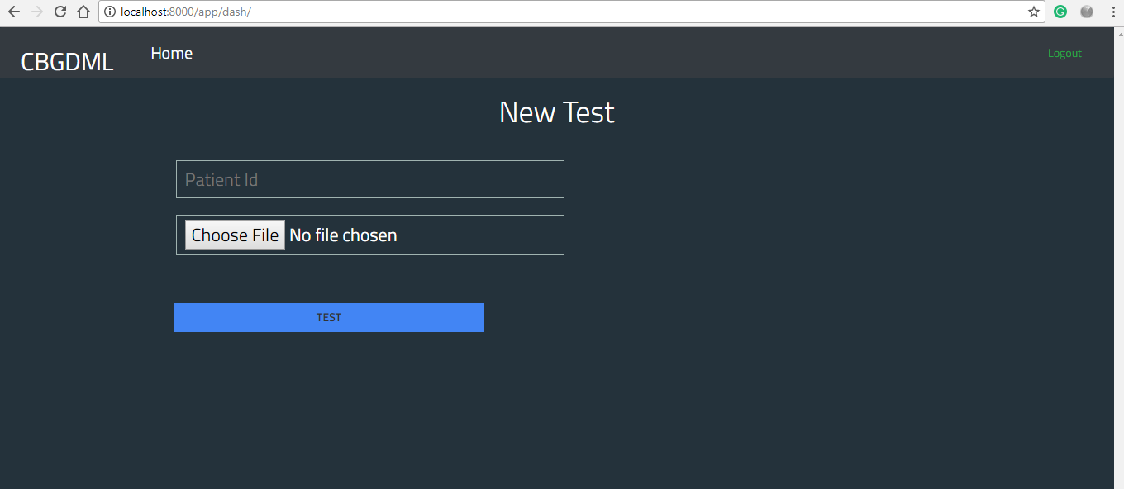

**Figure 7.2 Screenshot of Image Upload for Processing**

Figure 7.2 shows the screenshot of image upload for processing.Once the authentication is done, the doctor the is required to upload the image of the patient’s fundus image to the cloud for processing and prediction of CDR value for obtaining the severity and the presence of glaucoma. It is at this point the image is sent to the django server to be saved in the backend to be processed upon. The result of that process obtained in the next page.

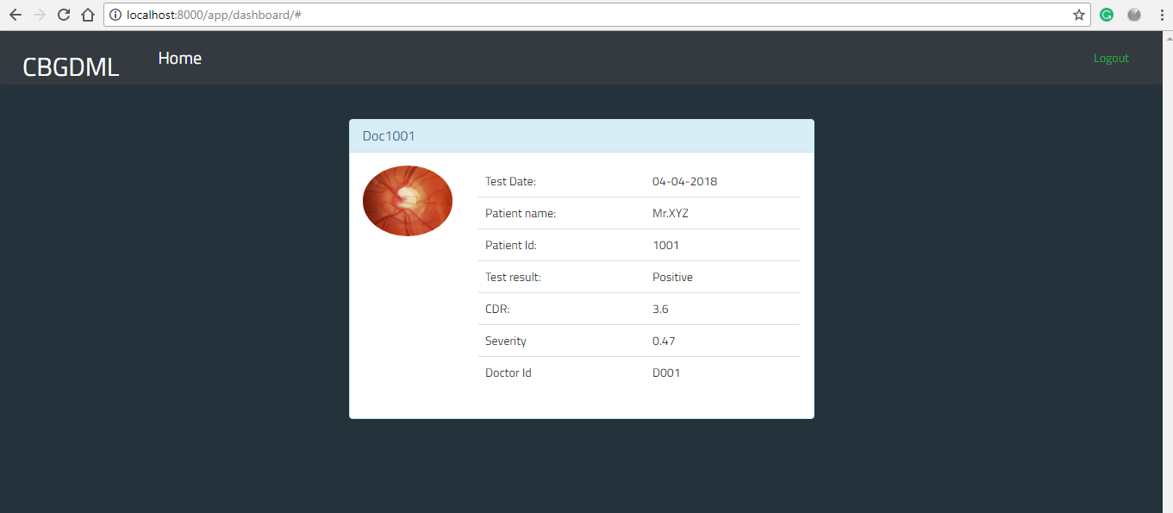

**Figure 7.3 Screenshot of User Report**

Figure 7.3 shows the screenshot of user report.After uploading of the fundus image is done, the doctor’s dashboard will display a detailed report. The report will have in it the fundus image the patient’s name & id along with the date of the test. It’ll also have The CDR value, the severity and will state whether glaucoma is present or not. These values are discrete to the doctor. That being said, it’s served only to the doctor as it is a detailed version of the report. These details make more sense at the hands of the doctor over the patient. The patient receives a more abstracted result on the web app.

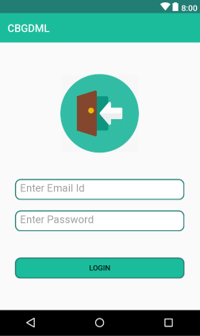

**Figure 7.4 Screenshot of App Login**

Figure 7.4depicts the login page of the android application dedicated specifically for the patient. The intent is to provide more convenience to the patient in viewing the result in a interactive and intuitive app that provokes the user to carry out the maintenance of his eye more frequently. This is accomplished by developing an engaging mobile application that allows for easy navigation and also provides a user friendly access of result of glaucoma tests done on the respective patient. The user is expected to enter his login credentials which then makes a request to the database to be authenticated and on successfully authentication the app takes on the patient to the subsequent services.

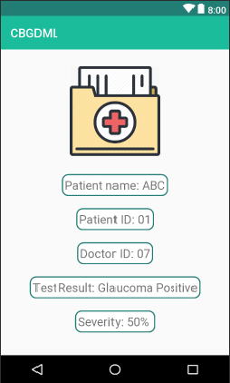

**Figure 7.5 Screenshot of user report on mobile app**

Figure 7.5 shows the screenshot of user report on mobile app. Once the user is authenticated he can then go to search for the specific test done on his/her eye by typing into the app the Test ID in the specified field. This runs the ID against the results database in the backend once the request is sent out from the app. The record matching the user entered id is retrieved and is converted to JSON (JavaScript Object Notation) before it is sent out the mobile. The secured JSON is then parsed through to obtain the required values to be displayed on screen. The result is abstracted and not as detailed as the one rendered to the doctor. Only the essential details that make sense to the patient is given out on the app display.

**CHAPTER 8**

**CONCLUSION AND FUTURE WORK**

**8.1 CONCLUSION**

Having said all the above, it is easy to understand the catastrophic nature of the disease of glaucoma and its seriousness. Glaucoma, being a deadly disease which has the potential to cause permanent blindness can ruins lives if left undetected and untreated. Enormous number of sufferings due to this disease have been recorded around the globe. Therefore the proposed model will be of great use to the patients as well as the doctors and on the whole, the field of medicine. The system has societal cause in it and that it helps improve the standards of people. With early detection the disorder can be well treated and the consequences can be mitigated well in advance.

**8.2 FUTURE ENHANCEMENT**

* The system is developed in only few platforms initially. They are Android and Web application. The future scope is to develop the system in different platforms.
* Also, the accuracy of the classifier model can be increased by training it with more datasets.
* The accuracy of the image cropping step in the image pre-processing model can be improved.

**APPENDIX 1**

**SAMPLE CODE**

**Image processing**

from PIL import Image

import numpy as np

import cv2

img = Image.open("gp1.jpg")

def cup(img):

gray = img.convert('L')

height = img.height

bw = gray.point(lambda x:0 if x<160 else 255,'1')

bw.save("result_cup.jpg")

img1 = cv2.imread('result_cup.jpg')

x = height / 2; y = 0;

width = img.width;

y1 = width - 1;

b = [255]

r = img1[x, y]

r1 = img1[x,y1]

while (np.any(b != img1[x, y])):

y = y + 1

r = img1[x, y]

while (np.any(b != img1[x, y1])):

y1 = y1 - 1

r1 = img1[x, y1]

img = cv2.imread("gp1.jpg")

roi = img[0:height, y:y1]

cv2.imwrite('cup.jpg', roi)

def disc(img):

gray = img.convert('L')

height = img.height

bw = gray.point(lambda x:0 if x<125 else 255,'1')

bw.save("result_disc.jpg")

img1 = cv2.imread('result.jpg')

x = height / 2;y = 0;

width = img.width;

y1 = width - 1;

b = [255]

r = img1[x, y]

r1= img1[x,y1]

while (np.any(b != img1[x, y])):

y = y + 1

r = img1[x, y]

while (np.any(b != img1[x, y1])):

y1 = y1 - 1

r1 = img1[x, y1]

img = cv2.imread("gp1.jpg")

roi1 = img[0:height, y:y1]

cv2.imwrite('disc.jpg', roi1)

**CDR Determination**

cup(img)

disc(img)

p_img = Image.open("cup.jpg")

p_img1 = Image.open("disc.jpg")

w1 = float(p_img.width)

w2 = float(p_img1.width)

ratio = round(w1/w2,2);

print "CDR =", ratio

**Machine learning Module**

import numpy as np

import matplotlib.pyplot as plt

import pandas as pd

from sklearn import datasets, linear_model

ds= pd.read_csv('GDS.csv')

X = ds.iloc[:,1].values

Y = ds.iloc[:,0].values

from sklearn.cross_validation import train_test_split

X_train,X_test,Y_train,Y_test = train_test_split(X,Y,train_size = 0.9 ,random_state = 0)

from sklearn.linear_model import LinearRegression

regressor = LinearRegression()

regressor.fit(X_train.reshape(-1,1), Y_train.reshape(-1,1))

inp = 0.30

Y_pred = regressor.predict(inp)

#print(X_test)

print(Y_pred)

**APPENDIX 2**

**SCREENSHOTS**



**Figure A2.1 Sign-up page of Web Application**

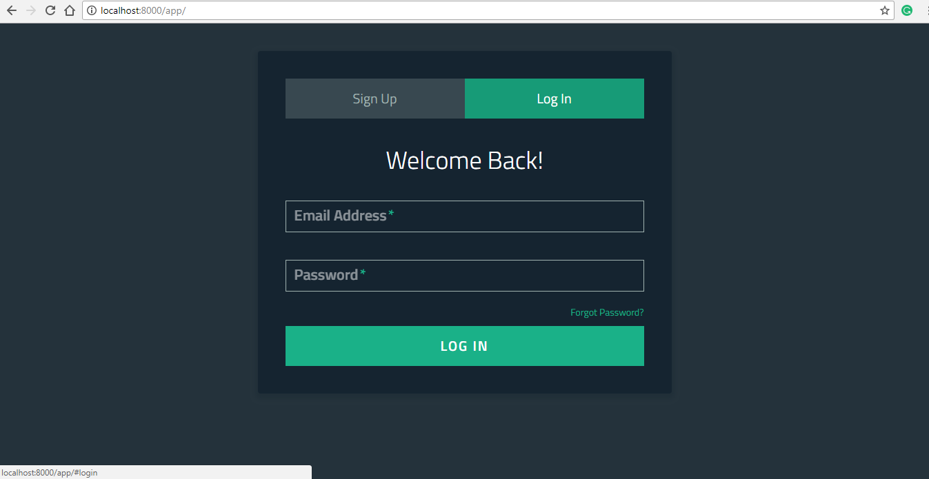

**Figure A2.2 Login page of Web Application**



**Figure A2.3 Uploading image for Test**



**Figure A2.4 Result Web Page**



**Figure A2.5 Login Page of mobile app**

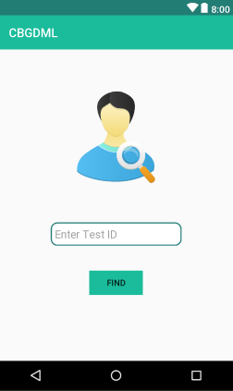

**Figure A2.6 Test ID finding page**



**Figure A2.7 Results in app**

**APPENDIX 3**

**PAPER PRESENTATION**

INTERNATIONAL CONFERENCE ON KNOWLEDGE BASED COMPUTING TECHNOLOGIES ON 06 APRIL 2018

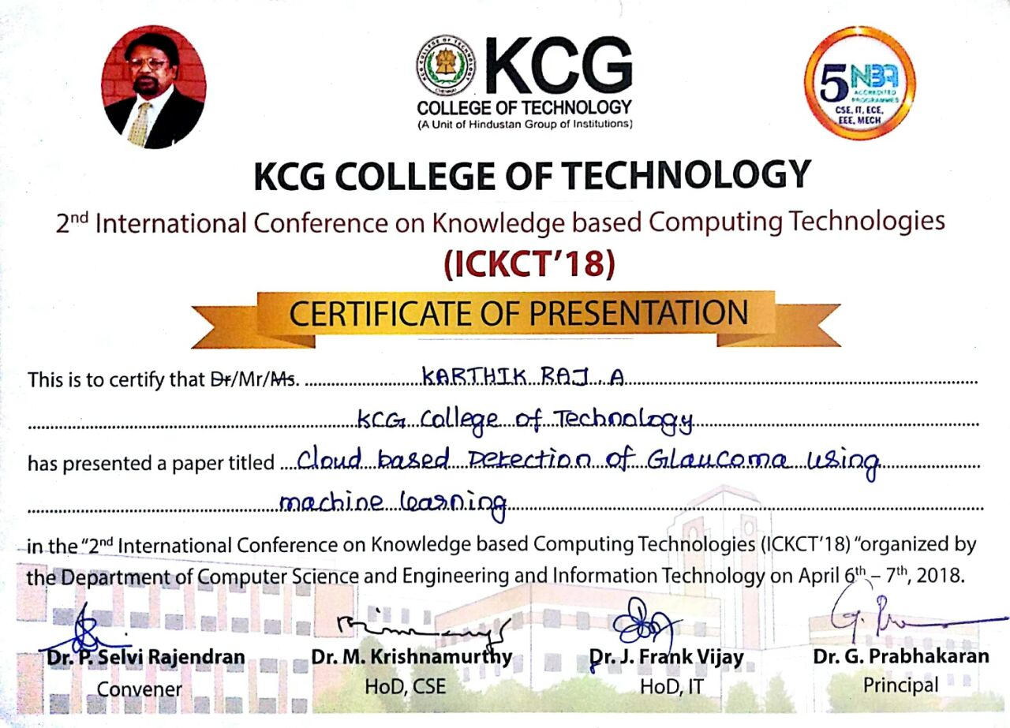





**CONFERENCE PAPER**

**Cloud based Detection of Glaucoma using machine learning**

Ashwath S1

Department of Computer Science and Engineering,

KCG College of Technology, Chennai. [mailaashoo@gmail.com](mailto:mailaashoo@gmail.com)

Balasubramaniam T1 Department of Computer Science and Engineering, KCG College of Technology, Chennai. [harishtheetharappan123@gmail.com](mailto:harishtheetharappan123@gmail.com)

Karthik Raj A1 Department of Computer Science and Engineering, KCG College of Technology, Chennai. [karthikraj3096@gmail.com](mailto:karthikraj3096@gmail.com)

Tamizhselvi SP2

Assistant Professor

Department of Computer Science and Engineering,

KCG College of Technology, Chennai. tamizhselvi.cse@kcgcollege.com

***Abstract: In the modern world, diseases have increased especially with the eye. Glaucoma is one such disease which has highly notorious effects. Glaucoma is an eye disorder which can affect a person of any age group. Glaucoma has permanent blindness as its at most consequence and, it has no symptoms at its early stages. It can only be detected in later stages which increases the consequences. The objective of this paper is to bring out a solution to detect glaucoma in its early stage using machine learning such that the effects of the disease can be reduced by early medication.***

***Keywords: Glaucoma, Machine Learning, Cloud Environment, Ophthalmological lens.***

1. INTRODUCTION

Eye is one of the best gifts mankind has ever had. Technically, it can be termed as one of the sensors of human body. Glaucoma is an eye disease which is the second most cause for blindness worldwide. Being an initially unnoticeable disorder, glaucoma will cause an irreversible vision loss by the time it is realized by the patient through vision difficulties. Glaucoma has no symptoms during its early stages which makes it more dangerous. Glaucoma arises from the retinal part of the eye. The primary effect of this disease is that it affects the drainage of aqueous fluids produced inside the eye. Due to this, the channel through which the aqueous fluids flow gets flooded being narrowed down or blocked. Having been associated with the higher-than-normal pressure inside the eye, it causes a condition called as ocular hypertension. Due to this the intensity of the disease climbs up and Glaucoma, if left untreated will first cause peripheral vision loss, eventually lead to complete blindness. This project aims at introducing machine learning to detect the disorder in its early stage. If the disease is detected in its early stage, the appropriate medication can be prescribed effectively**.** A mobile app, exclusively developed for this purpose will have the corresponding functionalities to capture, process and analyze the input images and run the classifier over it to give the result as well. Seeming technically feasible, this project will be of great use to the patients of this disease worldwide as it makes things happen artificially and automatically accurately.

On using the proposed system “Cloud Based Detection of Glaucoma using Machine Learning”, if Glaucoma is detected at early stages, it will be helpful to the doctors to treat the patients effectively. If the proposed system is implemented worldwide, it is definitely possible to reduce the risks of Glaucoma in a large scale and, the app will make sure that the diagnosed person with glaucoma is at ease while medicating glaucoma.

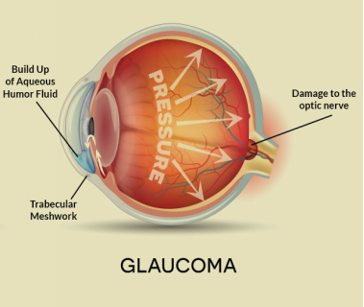

1. RELATED WORK

Detection of glaucoma at early stage is a boon to many with the disease. By early detection proper car could be given to the eye from the start, averting any hazardous consequences [4] & [7]. There are various techniques to do the same that [5] & [6]. These techniques involve the use of sophisticated equipment that weighs economically on the patient. Along with the use of the complicated machinery, the process itself is long and tedious as a result of which it’s not likable by many. Also glaucoma is a condition requiring frequent care and checking. If the process to do isn’t economically feasible, it cannot be performed by the patient as it should be. Glaucoma can be detected if the Cup to Disc ratio of the patient’s fundus image is obtained [1], [2], [4] & [7].Cup to disc ratio is a essential component to ease the detection of glaucoma. The cup and disc are the regions on the human eye covering the retinal eye space in where the optical nerves meet. As glaucoma progress the cup enlarges due to the intraocular pressure, this results in a higher Cup to Disc ratio value. This can be used to detect glaucoma’s presence in a patient.

To detect the Cup to Disc ratio it is essential to obtain the width of the stated. This can be accomplished by enforcing the ROI techniques over the respective fundus image [1]. There are many machine learning techniques to detect glaucoma [3], [5], [6]. Each can be put to use to detect glaucoma but they all vary in the accuracy of the prediction done. From the available machine learning techniques linear regression has the most accuracy to the scenario in concern [5]. The use of linear regression will result in prediction of glaucoma more accurately on ensuring that the linear regression model is well trained with a sufficiently large data set [2]. If trained properly the classifier will grow in its prediction accuracy

1. ARCHITECTURE

An android app is associated with this proposed system and it handles most of the parts of the system. Since android is most widely used, especially in India, it is being preferred to be developed first. The purpose of this app is to mainly capture the input image of the patient’s eye and forward it to the classifier in the cloud after processing it accordingly.

Ophthalmological lens is used in this proposed model to capture the fundus image. It is impossible to capture the image of the patient’s retina with a normal phone camera as it has fewer megapixels. Therefore, these lenses are specialized for this purpose and are put to use when the image is being captured. With the help of this lens one can obtain highly detail image of the patient’s retina. Only if the retinal image is accurate and detailed, it can be further processed and classified. Therefore the lens plays a major role in this proposed model.

The app is supposed to be very user friendly and can be made use of by both the patient and the doctor each having its own interfaces and user accounts. Initially the user must login to his respective account and there the interface appears according to the type of user. If the doctor logs in as the user, he can find options like Find patient, Patient Records, Analyze, and so on. If a patient logs in as the user, he can find options like Capture image, Analyze and Find doctor and so on. The appropriate users can access the appropriate functionalities and thus make the best use of the app. All the processing and analysis as well as classification processes occur in the cloud environment.

Cloud environment plays an important role in this proposed model as it deals with all the background processing and classification part. The image is captured using a mobile app using a phone device with ophthalmological lens as auxiliary. The captured image is forwarded to the cloud server as a raw input where it gets processed according to the requirement of the analysis part. The processing includes removing noise from the image, detecting the disc structure, cup structure and so on. Later the processed image is analyzed to detect the disc structure and on its detection the borders of the disc gets cropped. Similarly the cup part of the image gets cropped and based on these images the CDR determination is carried out. CDR Determination is a vital part of the proposed system in which the cup-to-disc ratio of the obtained image is calculated and stored. Following it, the obtained CDR value is applied to the Classifier. Based on the implementation in the classifier it gives out the results of the analysis. The result is then forwarded to the app.

The proposed system involves Machine learning. In fact, machine learning plays the key role in this proposed model. The cloud processes the image and determines the CDR value which is being applied to the classifier. The classifier is that which is used to classify the input image based on its results with the previous images. The classifier is made to learn the classification of the images by training it with numerous training and test sets. Initially numerous images are taken as training set and the system is trained with it. Then the classifier is tested with the test set. Based on all this, the classifier would have gained a good accuracy and based on it, the classifier give the result by implementing on the input image. This ion fact is one of the most complicated parts of the system and it plays a vital role in determining the results.

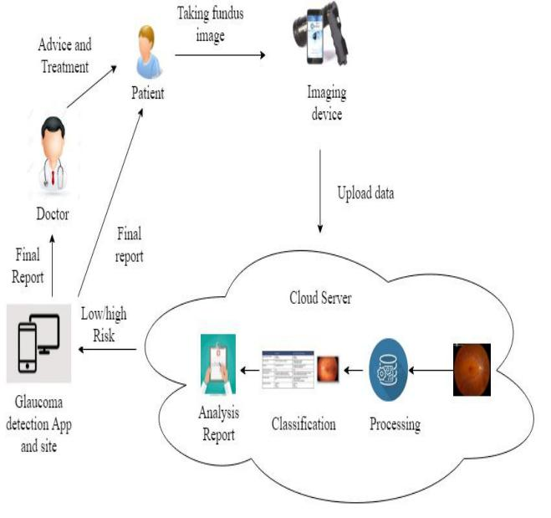

1. PROPOSED IMPLEMENTATION

The proposed model consists of a mobile app which basically deals with all the front end processes and functionalities of the system. Initially, the patient captures the image of his retina (Fundus image) with the Capture image option using the phone camera and ophthalmological lens. The captured input image is forwarded to the cloud. In the cloud the image is processed and is cleansed of contained noise for efficient and accurate processing. This is done by sharpening the image which in turn reduces the noise. The presence of noise can lead to the false prediction in the output. One the image is processed for noise removal the image is analyzed to detect the disc structure. The input image is converted to a black and white image and is then looped through, pixel by pixel from the center of the image, to obtain the first white pixel. This is the starting of the disc.

This also is the starting point of the width of the disc. This obtained disc is later put to use for deduce Cup to Disc value which is to be applied to the classifier to predict glaucoma. This is performed on all sides to obtain the pixels to crop the image which can later be used to discover the width of the cup. Eventually, by repeating the same process as that of determining width of disc, for the cropped image Cup to Disc ratio can be obtained by dividing them.

**Algorithm 1** Image processing and CDR determination

**Input :**

Img : Fundus Image

**Output :**

X : Cup to Disc Ratio value

1: Img = Image.open(image)  // Read input image

2: gray = img.convert('L')  //Convert to Binary image format

3: height = img.height   //Determine height

4: bw = **if** x<160 **then**  //Determine Intensity

5: x=0

6: else x=1

7: bw.save(“result_cup.jpg”) // save binary cup image

8: img1 = cv2.imread('result_cup.jpg') //Read the result image

9: x = height / 2, y =0 ,y1 = width - 1

10: **while**  Pixel = black do

11: increment y

12: **while** pixel = black do

13: decrement y1

14: roicup = img [0->height , left(y)->right(y1)]  //Region of interest cup

15: **Repeat** steps **1** to **12** for disc

16: roidisc = img[0-> height, left(y)->right(y1)]  //Region of interest disc

17: w1 = float(p_img.width) //Determine the cup diameter w1

18: w2 = float(p_img1.width)  //Determine the disc diameter w2

19: X = round(w1/w2,2)  //Determine the ratio

With the CDR value, the classification process is carried out to detect glaucoma. It is done by applying the CDR value to the highly trained classifier. The classifier gives out the result as output with glaucoma’s severity. Linear Regression is the employed algorithm to train the classifier as it has the highest accuracy in classification. Linear regression is a regression technique that uses statistical principles to predict or classify the quantity based on the input. It does so by developing a line called best fitting line, by treating the input dataset as coordinates of a graph. It obtains the slope and intercept for best fitting line from these coordinates, the best fitting line is the only line of all possible lines that can drawn through these points, with minimum distance to all the points. Once that is obtained, the input, Cup to disc value is fed to the classifier. It predicts the output by calculating its position in graph with respect to the best fitting line for the input.

**Algorithm 2**Machine learning classifier

**Input :**

X : CDR value

x : CDR values of input dataset

y : severity of respective CDR values of input dataset

xi & yi are the ith value of x and y

**Output :**

Y : is the predicted severity

B0: is the intercept of best fitting line

B1: is the slope of best fitting line

1: ds = pd.read_csv(“dataset.csv”) // Get the input dataset

2: j = sum((xi - mean(x)) * (yi - mean(y)))

3: k = sum((xi – mean(x))2)

4: B1 = j/k

5: B0 =  mean(y) – B1 * mean(x)

6: Y =   B0 + B1 * x

The output is forwarded to the app and thus the patient obtains the result. Based on the result, the patient can seek a doctor’s advice and follow medication.

1. CONCLUSION

Having said all the above, it is easy to understand the catastrophic nature of the disease of glaucoma and its seriousness. Glaucoma, being a deadly disease which has the potential to cause permanent blindness can ruins lives if left undetected and untreated. Enormous number of sufferings due to this disease has been recorded around the globe. Therefore the proposed model will be of great use to the patients as well as the doctors and on the whole, the field of medicine. The system has societal cause in it and that it helps improve the standards of people. With early detection the disorder can be well treated and the consequences can be mitigated well in advance.

REFERENCES

[1] J. Ayub *et al*., "Glaucoma detection through optic disc and cup segmentation using K-mean clustering," *2016 International Conference on Computing, Electronic and Electrical Engineering (ICE Cube)*, Quetta, 2016, pp. 143-147.

[2] A. A. Salam *et al*., "Benchmark data set for glaucoma detection with annotated cup to disc ratio," *2017 International Conference on Signals and Systems (ICSigSys)*, Sanur, 2017, pp. 227-233..

[3] T. Khalil, M. U. Akram, S. Khalid and A. Jameel, "An overview of automated glaucoma detection," *2017 Computing Conference*, London, 2017, pp. 620-632.

[4] S.kavitha,S.karthikeyan and Dr.K.Duraiswamy(2010),”Early Detection of Glaucoma in Retinal images Using Cup to Disc Ratio”, *2010 Second International conference on Computing, Communication and Networking Technologies.*

[5] T. Khalil, S. Khalid and A. M. Syed, "Review of Machine Learning techniques for glaucoma detection and prediction," *2014 Science and Information Conference*, London, 2014, pp. 438-442

[6] S. Nawaldgi, "Review of automated glaucoma detection techniques," *2016 International Conference on Wireless Communications, Signal Processing and Networking (WiSPNET)*, Chennai, 2016, pp. 1435-143

[7] D. D. Patil and R. R. Manza, "Design new algorithm for early detection of primary open angle glaucoma using retinal Optic Cup to Disc Ratio," *2016 International Conference on Electrical, Electronics, and Optimization Techniques (ICEEOT)*, Chennai, 2016, pp. 148-151.

**REFERENCES**

1. A. A. Salam (2017), "Benchmark data set for glaucoma detection with annotated cup to disc ratio," International Conference on Signals and Systems (ICSigSys), Sanur, pp. 227-233.
2. A.A.Salam, M.U.Akram, T.Khalil (2016), ”Automated detection of glaucoma using structural and non structural features” SpringerPlus, p.1519.
3. A. A. Salam, M. U. Akram, K. Wazir and S. M. Anwar (2015), "A review analysis on early glaucoma detection using structural features," IEEE International Conference on Imaging Systems and Techniques (IST), Macau, pp. 1-6.
4. A. Jameel, M. U. Akram, S. Khalid, T. Khalil (2017), "An overview of automated glaucoma detection," Computing Conference, London, pp. 620-632.

1. Baidaa Al-Bander, Bryan M. Williams, Majid A. Al-Taee, Waleed Al-Nuaimy, Yalin Zheng (2017), "A Novel Choroid Segmentation Method for Retinal Diagnosis Using Deep Learning", Developments in eSystems Engineering (DeSE) 10th International Conference on, pp. 182-187.
2. J. Ayub (2016), "Glaucoma detection through optic disc and cup segmentation using K-mean clustering", International Conference on Computing, Electronic and Electrical Engineering (ICE Cube), Quetta, 2016, pp. 143-147.
3. J.Hornegger, J.Meier, J. Michelson, L.G Nyúl ,R. Bock (2007), “Classifying Glaucoma with Image-Based Features from Fundus Photographs”, Springer, Berlin, Heidelberg,  pp. 355-364
4. S. Nawaldgi (2016), "Review of automated glaucoma detection techniques", International Conference on Wireless Communications, Signal Processing and Networking (WiSPNET), Chennai, pp. 1435-1438.
5. V. Thangaraj and V. Natarajan (2017), "Glaucoma diagnosis using support vector machine", International Conference on Intelligent Computing and Control Systems (ICICCS), Madurai, pp. 394-399.